# Comparison from Stata mimix output with R output for 3 different data sets

## Estimates for J2R option – jump to reference

Using Stata command

mimix fev treat, id(id) time(time) method(j2r) refgroup(2) covariates(base) clear m(10000) seed(301)

The Following shows Stata and R outputs, both J2R method, reports estimates for some individuals

**Asthma data**

**Comparing M imputed estimates for individual id=5456, asthma data**

Figure R estimates

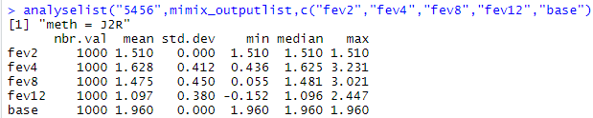

Figure Stata estimates

Ts v R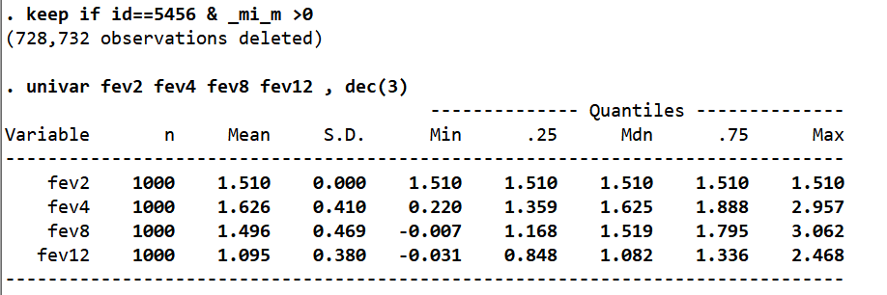

**Regression outputs from Stata v R**

Figure regress option in mimix

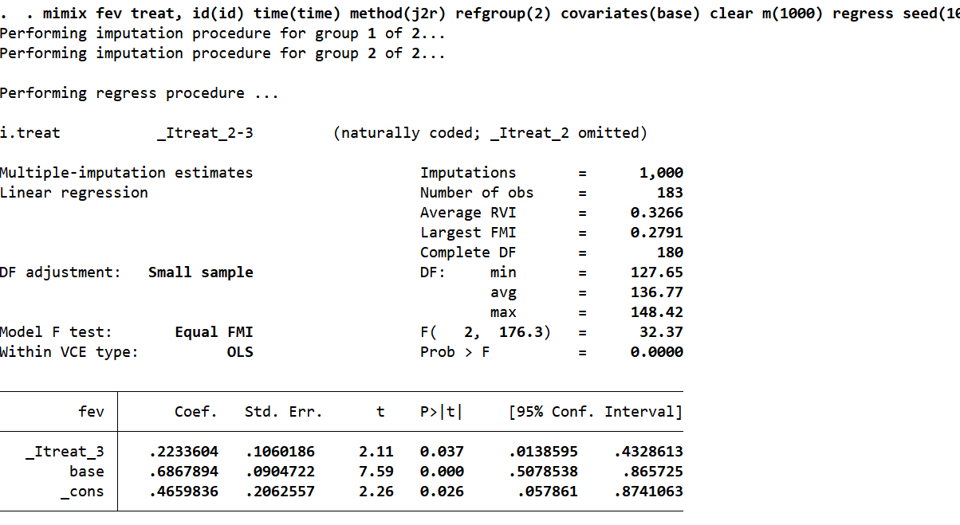

Figure miInference in R

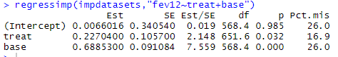

**Outputs for id = 5051, the patt=13 , one patient**

Figure Stata estimates

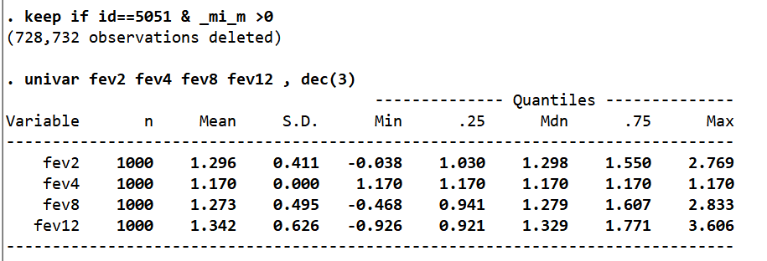

Figure R estimates

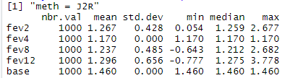

pttestf(1000,1000,1.237,0.485,1.273,0.495)

[1] 0.05029705

Figure Figure 5 input data showing missing data pattern id=5051

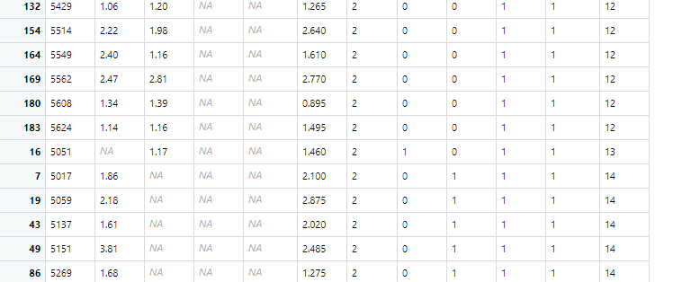

**Outputs for id = 5435,**

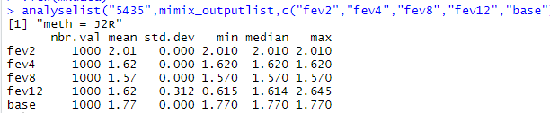

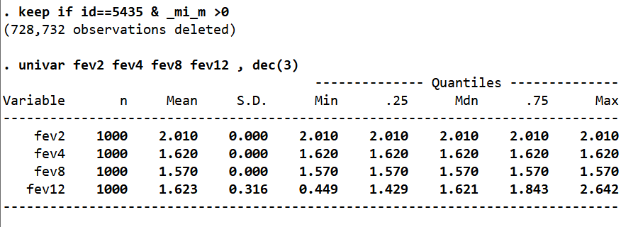

**Accupuncture data**

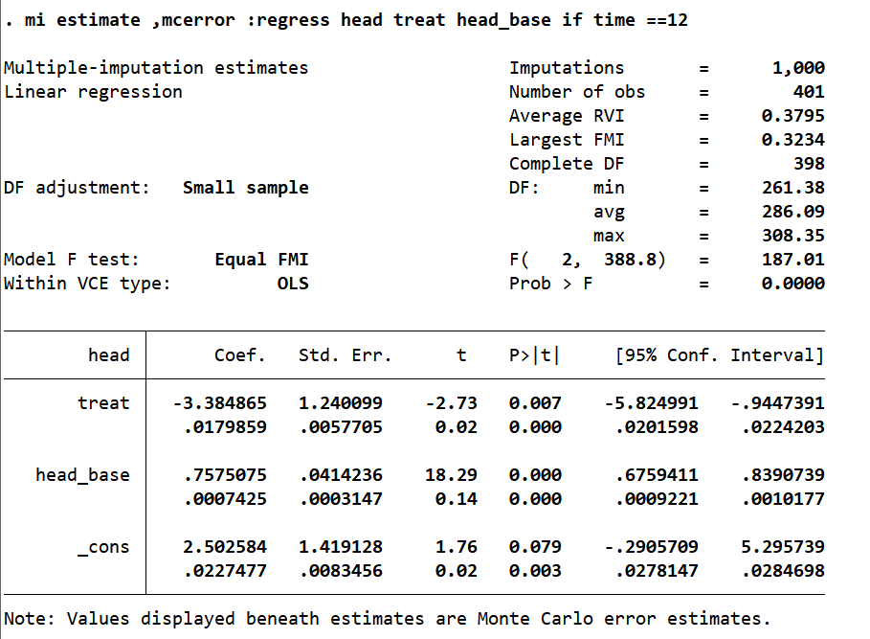

Figure R regression output

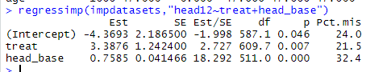

**Outputs for id = 100,**

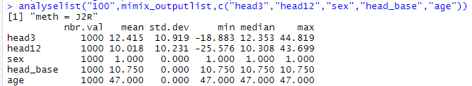

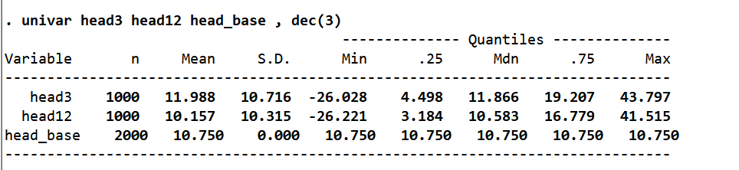

pttestf(1000,1000,11.988,10.716,12.415,10.919)

[1] 0.1887777

Outputs for id =151

Figure R estimates for id=151

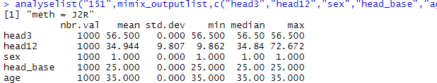

Figure Stata estimates

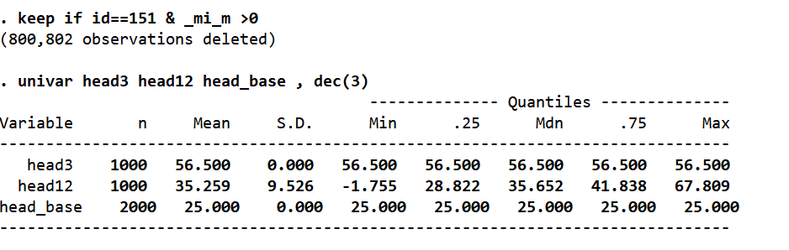

Regression outputs by Rubins rules, adding covariates +sex+ age

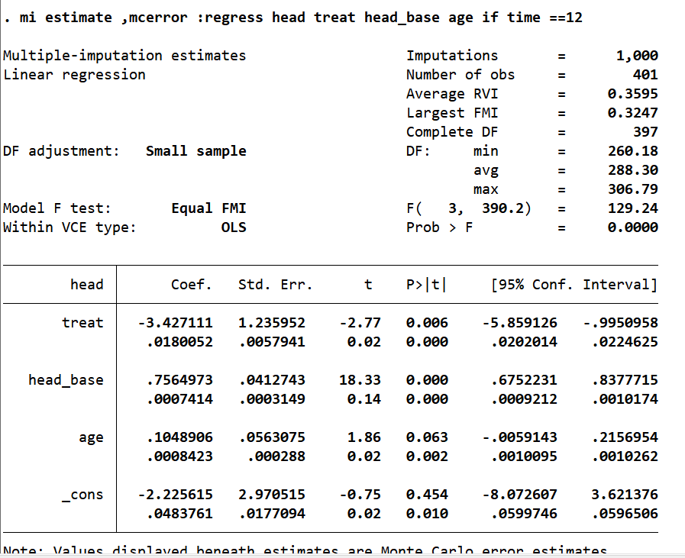

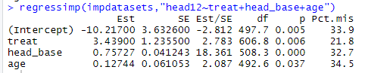

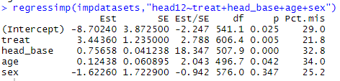

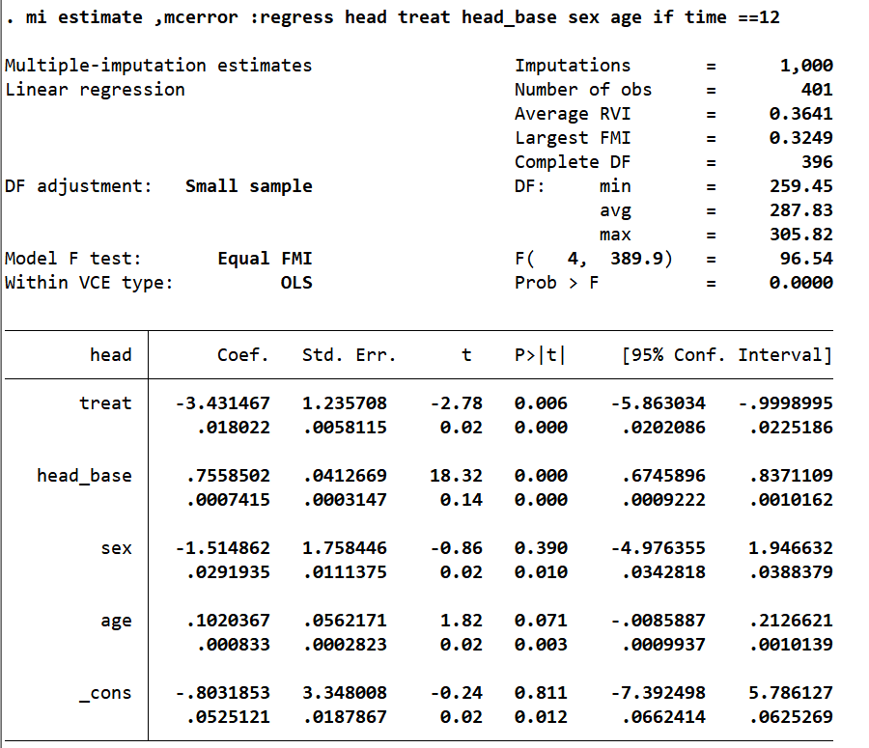

**Anti-depressant data**

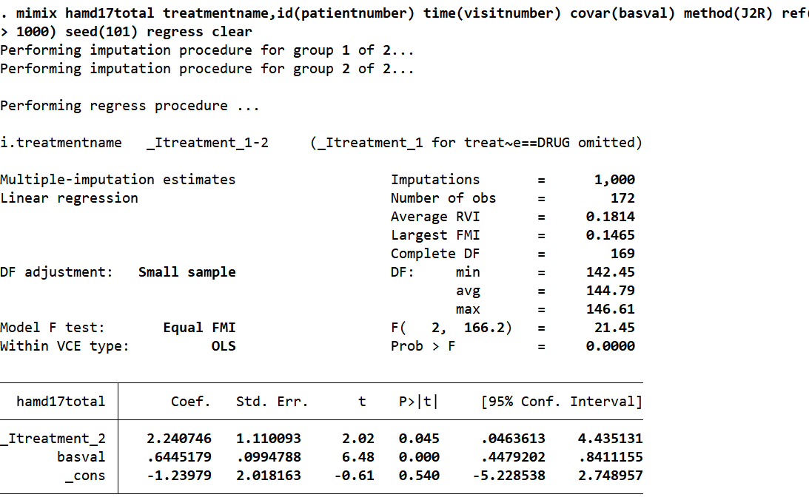

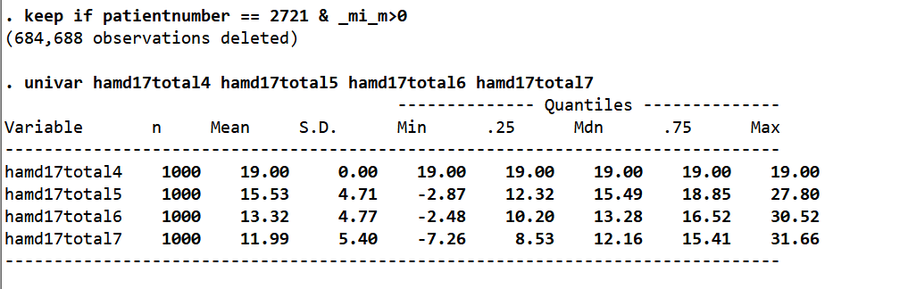

Figure R outputs Runmimix(c("basval"),"HAMD17.TOTAL","TREATMENT.NAME","PATIENT.NUMBER","VISIT.NUMBER",10,"DRUG","J2R",101,c("jeffreys"))

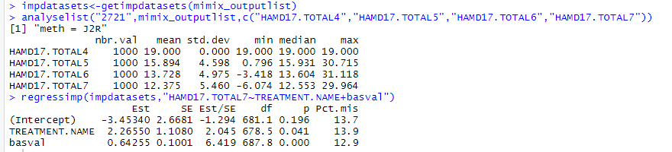

Appendix

Figure SAS routine for J2R

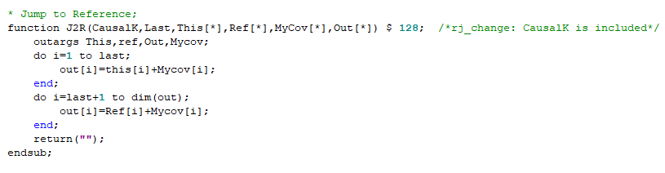

Figure message from emNorm in r

